Spelling | Handwriting | Punctuation
Can spell all words on year 5 / 6 spelling list  Can usually correct spellings in independent writing | Write legibly, fluently and with increasing speed by choosing which shape of a letter to use when given choices and deciding whether or not to join specific letters  Choosing the writing implement that is best suited for a task. | Accurately punctuates all parts of speech.  Use apostrophes correctly  Uses commas to clarify meaning or to avoid ambiguity  Uses hyphens to avoid ambiguity  Uses brackets, dashes or commas for parenthesis  Uses semi-colons or dashes to mark boundaries  Uses a colon to introduce a list  Punctuates bullet points consistently
Sentence structure / organisation | Vocabulary and grammar | Editing and redrafting
In writing narratives, considering how authors have developed characters and  settings in what pupils have read, listened to or seen performed  Writes longer passages  Using a wide range of devices to build cohesion within and across paragraphs  using further organisational and presentational devices to structure text and to guide the reader [for example, headings, bullet points, underlining] | Uses a full range of sentences, conjunctions, nouns, verbs, adjectives and adverbs, accurately, consistently, and for effect  Uses relative clauses beginning with WHO, WHICH, WHERE, WHEN, WHOSE, THAT or with an implied relative pronoun  Uses expanded noun phrases to convey complicated information concisely  Uses passive verbs to affect the presentation of information in a sentence  Uses modal verbs or adverbs to indicate degrees of possibility  Uses the perfect form of verbs to mark relationships of time and cause | Consistent and correct use of tense throughout a piece of writing  Correct subject and verb agreement when using singular and plural  Proof-reads for spelling and punctuation errors  Draft and write by selecting appropriate grammar and vocabulary, understanding how such choices can change and enhance meaning;  in narratives, describing settings, characters and atmosphere and integrating dialogue to convey character and advance the action;  précising longer passages
Sentence types | Genres | Poetry – performance and reading
Outside (inside)  Two related sentences that tell us what a character has done and related inner feeling.  Irony sentence  Deliberately overstates how good or bad something is | Stories  Stories that go back in time  Recount  Instructions  Letters  Non chronological reports  Persuasive writing/ adverts  Myths, legends, fables  Arguments  News reports  Explanations  Playscripts  Balanced persuasions  Diaries  Biographies and autobiography Biographies and autobiographies | Interpret poems, explaining how the poet creates shades of meaning;  justify own views and explain underlying themes  explain the impact of figurative and expressive language, including  metaphor;  comment on poems’ structures and how these influence meaning  learning a wider range of poetry by heart  preparing poems and plays to read aloud and to perform,  showing understanding through intonation, tone and volume so that the meaning is clear  to an audience improving performances vary pitch, pace volume, rhythm and expression in relation to the poem’ meaning and form  use actions, sound effects, musical patterns, images and dramatic  interpretation, varying presentations by using ICT
Poetry – writing | Poetry - classics | Parody and fairy tale
Rap use language imaginatively to  create surreal, surprising, amusing  and inventive poetry;  use simple metaphors and personification to create poems  based on real or imagined experience;  select pattern or form to match meaning and own voice poems  Metaphor poems  Monologues  Cinquains  Discuss analogy in poetry  Benjamin Zephaniah  Christina Rosetti – comparing 2 contrasting poets | The Jabberwocky- Carroll  Poems by Christina Rosetti-  From a Railway Carriage-  Stephenson | Hansel and Gretel – parody versions

Year 6 Genre Checklist
Stories including stories that go back in time | 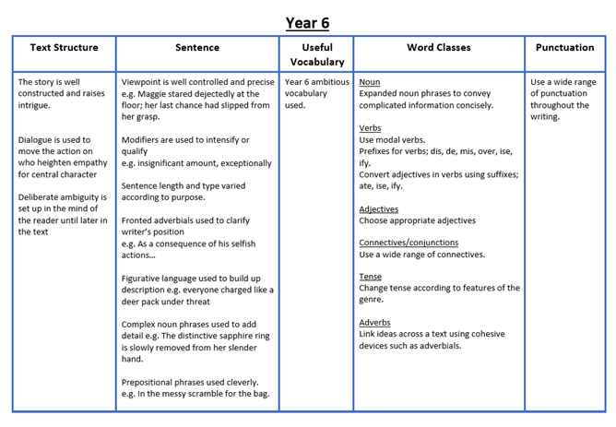
Instructions | 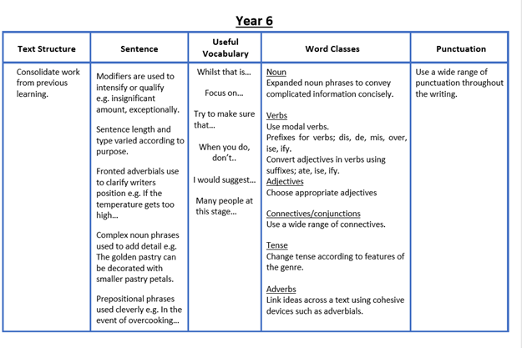
Recounts /diaries | 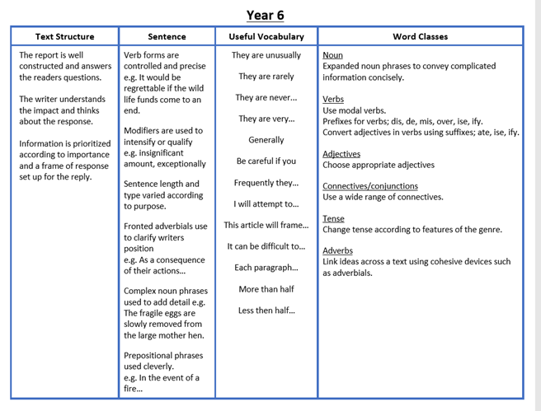
Letters | 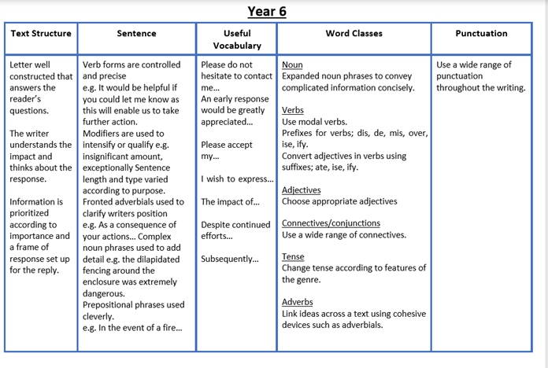
Non chronological reports | 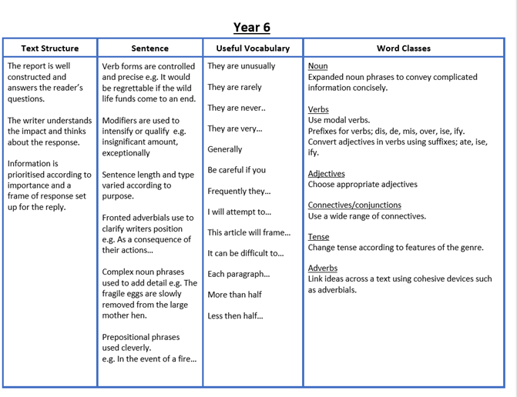
News Reports | 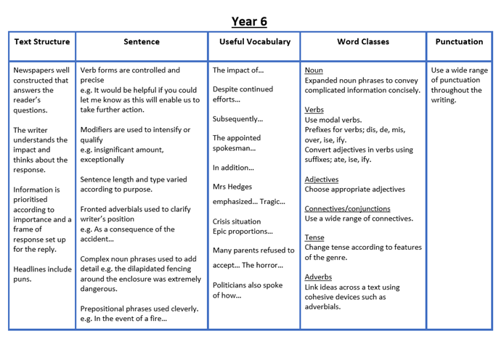
Explanations | Text structure sentence Useful vocab Word classes punctuation  Continue with established form Opening to include fact, therefore Use of short sentences mixed with extended sentences Subordinate clauses Comparing then and now in opening De:de sentence All causal conjunctions Chronological Adverbs for degrees Noun phrases Purposeful verb choices Cause and effect conjunctions Specific time adverbials Parenthesis for drop ins ! for end statement Commas after time adverbs and adverbials Semi colons to separate clauses
Biographies and autobiographies | 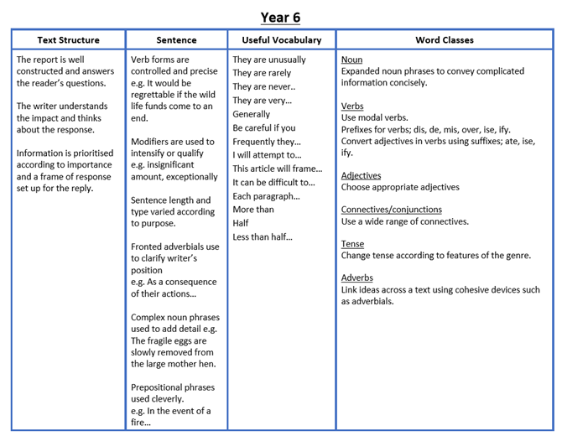
Playscripts | Text structure Sentence Useful vocab Word classes Punctuation  Absence of speech marks and omission of word ‘said’ Name of character on left hand side Each new speech on new line Stage direction in brackets Varied sentence length is purposeful. Explore changing the place of the subordinate clause in the sentence. Recognition that speech uses contractions as informal language form. Including adverbs/ adverbials in all stage instructions Ensure the setting has specific use of noun phrases Correct use of commas, full stops, exclamation and question marks, colons, semi colons brackets and ellipses and editing for correct use of these.
Argument texts | 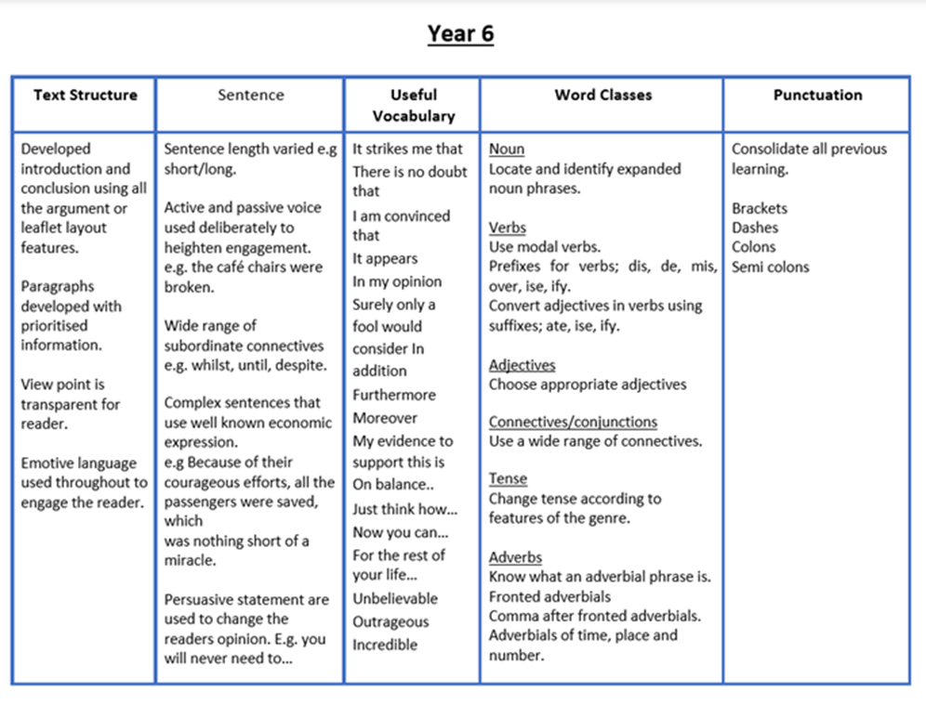
Balanced discussions | 